PROJECT DESIGN PHASE – 3
Proposed Solution
Date | 30 September 2026
Team ID | SWTID-2026-2597
Project Name | Streamlining IT Procurement – Automating Standard Laptop Orders with Flow Designer
Team Leader | SANTHIYA M
Maximum Marks | 2 Marks

Team Members
- SRIDHARSHINI T
- SARAL NILA M
- ROSHINI R / RITHIKA S
Proposed Solution Template
S.No. | Parameter | Description
1 | 1. Problem Statement (Problem to be solved) | Standard Laptop procurement requires manual coordination for task creation and Hardware assignment, which can cause delays and user waiting time.
2 | 2. Idea / Solution description | Create a ServiceNow Flow Designer flow named “Standard laptop task”. When the Standard Laptop catalog request is triggered, the flow creates a Catalog Task automatically.
3 | 3. Novelty / Uniqueness | The solution connects the Service Catalog directly to Flow Designer automation so that the required Hardware task is generated consistently with predefined values.
4 | 4. Social Impact / Customer Satisfaction | Reduces waiting time and manual follow-up for employees, gives the IT team clear task ownership, and improves the overall procurement experience.
5 | 5. Business Model (Revenue Model) | Internal IT process improvement. The organization gains value through reduced manual effort, better resource utilization and faster laptop provisioning rather than direct customer revenue.
6 | 6. Scalability of the Solution | The same Flow Designer pattern can be extended to other standard hardware items such as monitors, keyboards, desktops and accessories by adding suitable catalog triggers and task rules.
Proposed Solution Flow
Standard Laptop Catalog Item → User Places Order → Request Created → Request Approved → Requested Item Generated → Flow Designer Triggered → Catalog Task Created → Hardware Group → Laptop Configuration
Phase 3 Outcome
The proposed solution provides an automated and scalable approach for standard laptop procurement, with clear task ownership and reduced manual intervention.

Reference Template
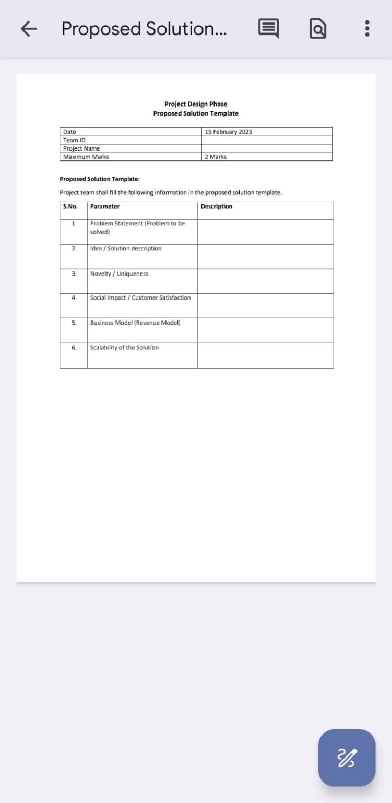
Reference: Proposed Solution template supplied for the project.

